Business analyst

A business analyst (BA) is a professional who analyzes business processes, products, services, and software to improve business efficiency. They use data to identify issues and recommend solutions to increase productivity, profitability, and efficiency.

**Here are some of the tasks and responsibilities of a business analyst:**

* **Identify needs**: Identify and prioritize the technical and functional needs of the organization
* **Analyze data**: Use tools like SQL and Excel to analyze large data sets
* **Create financial models**: Create financial models to support business decisions
* **Understand business**: Understand the business's strategies, goals, and requirements
* **Plan enterprise architecture**: Plan the structure of the business
* **Document requirements**: Document requirements clearly and concisely to create a blueprint for the project
* **Communicate with stakeholders**: Act as a point of contact for business stakeholders and IT teams
* **Lead conferences and workshops**: Lead conferences and workshops

**Skills of the Business analyst**

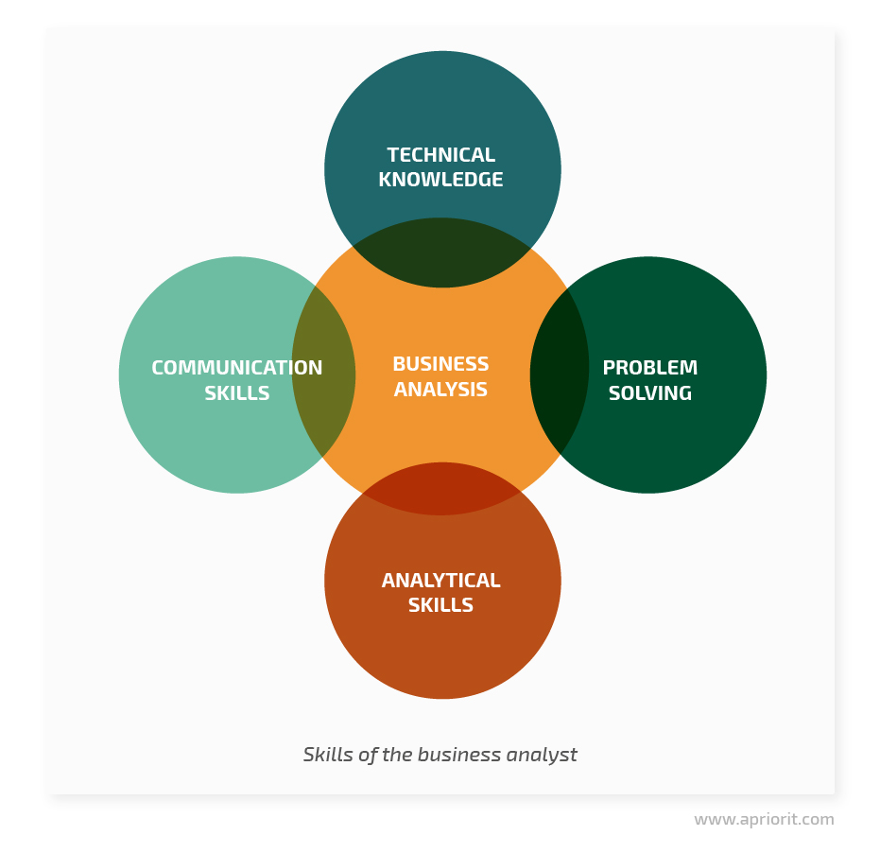

* **Technical Knowledge** : The ability to use software to analyze data and create presentations .
* **Problem-solving**: The ability to identify problems, determine their causes, and create solutions
* **Analytical thinking**: The ability to gather, interpret, and analyze data to identify trends and draw conclusions
* **Communication Skills**: The ability to clearly and efficiently convey information through speaking and writing

**SDLC**

**SDLC is a process followed for software building within a software organization.**SDLC consists of a precise plan that describes how to develop, maintain, replace, and enhance specific software. The life cycle defines a method for improving the quality of software and the all-around development process.

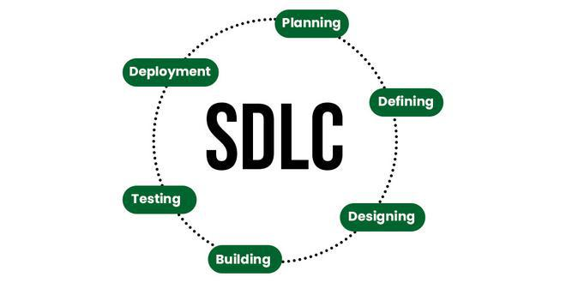

**Stages of the Software Development Life Cycle**

**SDLC specifies the task(s) to be performed at various stages by a software engineer or developer. It ensures that the end product is able to meet the customer’s expectations and fits within the overall budget. Hence, it’s vital for a software developer to have prior knowledge of this software development process. SDLC is a collection of these six stages, and the stages of SDLC are as follows:**

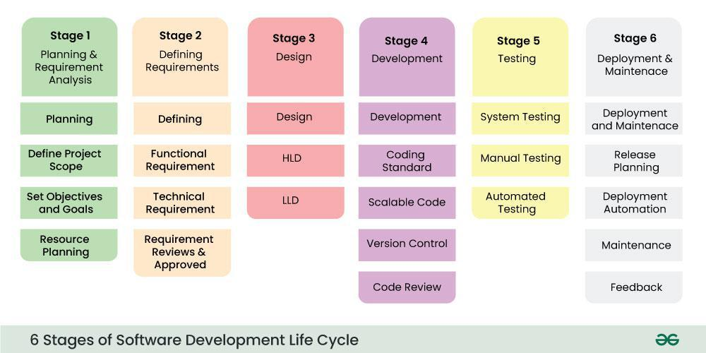

**Agile sprint**

**An agile sprint is a short, repeatable phase of work in an agile project that's typically one to four weeks long. The goal of an agile sprint is to quickly deliver new functionality or improvements to customers.**

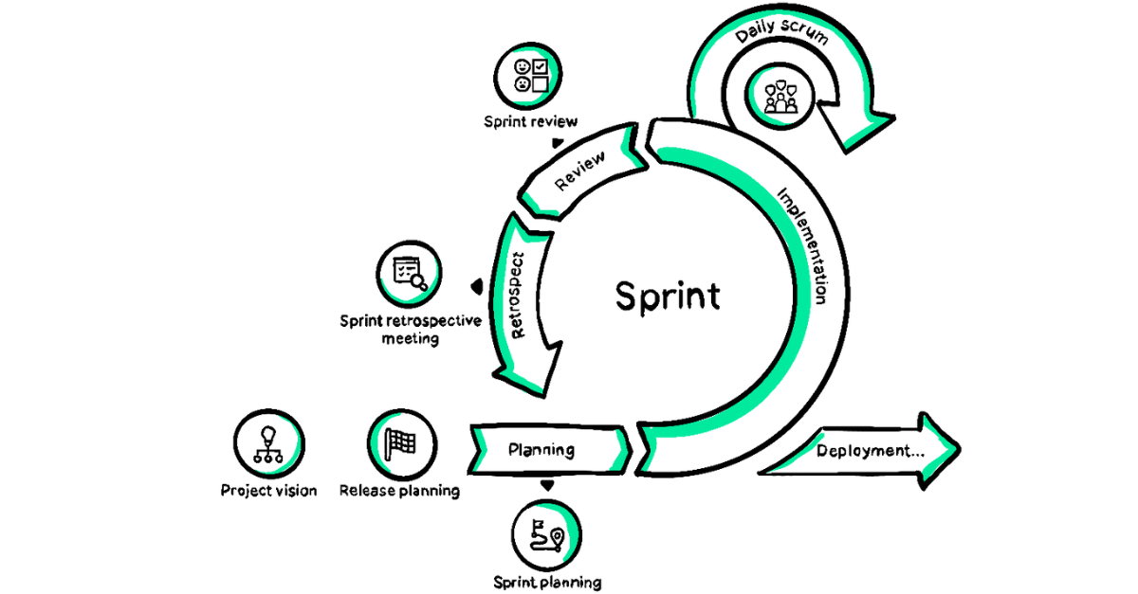

**Here are some key aspects of agile sprints:**

* **Sprint planning: A collaborative meeting between the product owner, Scrum master, and development team to agree on the sprint's goals, tasks, and criteria for acceptance.**
* **Sprint backlog: A list of tasks and potential product changes that the team will complete during the sprint.**
* **Daily scrum: A short meeting where the team discusses what they've accomplished, what they'll work on next, and any obstacles.**
* **Sprint review: A meeting where the team shows their work to the product owner.**
* **Sprint retrospective: A meeting where the team discusses ways to improve the product.**

**Agile sprints encourage iterative development and continuous improvement, which can help organizations produce quality software faster and at a lower cost.**

**SPRINT PLANING PROJECT**

|  |  |  |  |  |  |
| --- | --- | --- | --- | --- | --- |
| Building Construction | | |  |  |  |
|  |  |  |  |  |  |
|  |  |  |  |  |  |
| **Project Name** | Building Construction | | | | |
| **User Story** | Plan for a building construction project involves breaking the overall project into 8 manageable phases. With each sprint lasting around 2 weeks. The project will be divided into tasks such as site preparation. Foundation work, framing, electrical, plumbing installation, finishing and inspection. | | | | |
| **Project Manager** | XYZ | | | | |
| **Duration** | 8 months | | | | |
| **Start date** | 1/6/2024 | | | | |
| **End Date** | 28/2/2025 | | | | |
| **Sprint Duration** | 2 Weeks Per Sprint | | | | |
| **Sprint Goal** | Complete critical construction milestones to ensure steady progress toward the building's completion | | | | |
| **Budget** | 20,00,000/- | | | | |